Banking System

* Subject : Object oriented modeling and design
* Name : 1. Parekh Vishal (16BCP026)

2. Patel Tirth (16BCP056)

3. Patel Yash (16BCPD090)

* This banking system project in C++ is a simple console application developed C++.In this project user can access it’s bank account from this software in bank.There are no necessary of a cashier in bank for operate banking operation like deposit money ,withdraw money etc.In this software user can create a new account in bank,user can create current account and saving account also as per it’s reqirement and also perform operation like deposit money,withdraw money.The whole data of user are store at certain file named “data.txt”,and user’s Username and password stored at other file due to security purpose. We also improve this software by adding features like loan request,interest count and transfer money form one account to other account etc.Here we trying to make simple bank application.
* For transaction of money there are dedicate machine at bank which count amount money which user enter in our software and perform transaction.
* Here one base class named User and it’s two derived class named exi_user and new_user.
* When a new user come to bank to create an account then asked to user which type of account do you want to create for that two derived class from class new_user named class sa and class ca.
* Class sa for create saving account and class ca for creating current account.
* Here we put constrain for creating saving account that user need to deposit minimum 500 rupees and same for current account user but minimum amount to be deposit is 5000.
* Class transaction came in picture when user wants to perform operation like deposit money and withdraw money.
* Class Diagram :

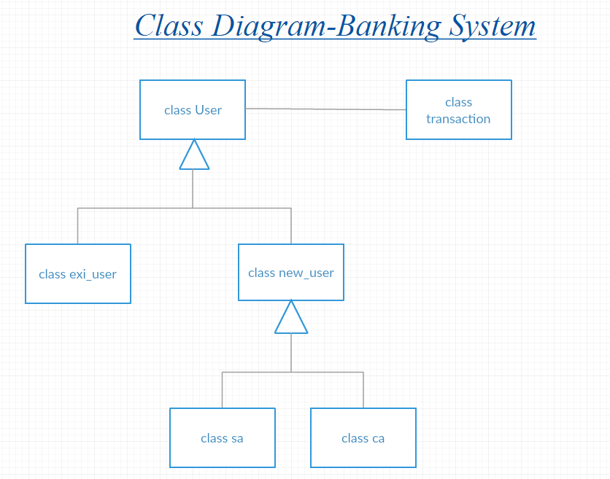

* Use-case Diagram :

